

Semester Two Examination, 2016

Question/Answer Booklet

MATHEMATICS
SPECIALIST
UNITS 3 AND 4

Section One:

Calculator-free

Your name

Time allowed for this section
Reading time before commencing work: five minutes
Working time for section: fifty minutes

Materials required/recommended for this section
To be provided by the supervisor
This Question/Answer Booklet
Formula Sheet

To be provided by the candidate
Standard items: pens (blue/black preferred), pencils (including coloured), sharpener, correction fluid/tape, eraser, ruler, highlighters

Special items: nil

Important note to candidates
No other items may be taken into the examination room. It is your responsibility to ensure that you do not have any unauthorised notes or other items of a non-personal nature in the examination room. If you have any unauthorised material with you, hand it to the supervisor before reading any further.

Structure of this paper

Section | Number of questions available | Number of questions to be answered | Working  time (minutes) | Marks available | Percentage of exam
Section One:  Calculator-free | 8 | 8 | 50 | 53 | 35
Section Two:  Calculator-assumed | 13 | 13 | 100 | 97 | 65
 |  |  | Total | 150 | 100

Instructions to candidates

1. The rules for the conduct of examinations are detailed in the school handbook. Sitting this examination implies that you agree to abide by these rules.

2. Write your answers in this Question/Answer Booklet.

3. You must be careful to confine your response to the specific question asked and to follow any instructions that are specified to a particular question.

4. Spare pages are included at the end of this booklet. They can be used for planning your responses and/or as additional space if required to continue an answer.
- Planning: If you use the spare pages for planning, indicate this clearly at the top of the page.
- Continuing an answer: If you need to use the space to continue an answer, indicate in the original answer space where the answer is continued, i.e. give the page number. Fill in the number of the question that you are continuing to answer at the top of the page.

5. Show all your working clearly. Your working should be in sufficient detail to allow your answers to be checked readily and for marks to be awarded for reasoning. Incorrect answers given without supporting reasoning cannot be allocated any marks. For any question or part question worth more than two marks, valid working or justification is required to receive full marks. If you repeat any question, ensure that you cancel the answer you do not wish to have marked.

6. It is recommended that you do not use pencil, except in diagrams.

7. The Formula Sheet is not to be handed in with your Question/Booklet.

Section One: Calculator-free 35% (53 Marks)
This section has eight (8) questions. Answer all questions. Write your answers in the spaces provided.

Working time for this section is 50 minutes.

Question 1 (6 marks)
The polynomial $h\left(z\right)=z^{4}-4z^{3}+17z^{2}-16z+a$, where $a$ is a real constant, is exactly divisible by $\left(z-2i\right).$
- Determine the value of $a$. (2 marks)

- Write down two zeros (roots) of $h(z)$. (1 mark)

- Determine the other zeros of $h(z)$. (3 marks)

Question 2 (5 marks)
Let

(a) Express $v$ in polar form. (2 marks)

(b) Show that $v^{4}=-1$. (1 mark)

(c) Plot the roots of $z^{4}+1=0$ on the following Argand diagram. (2 marks)

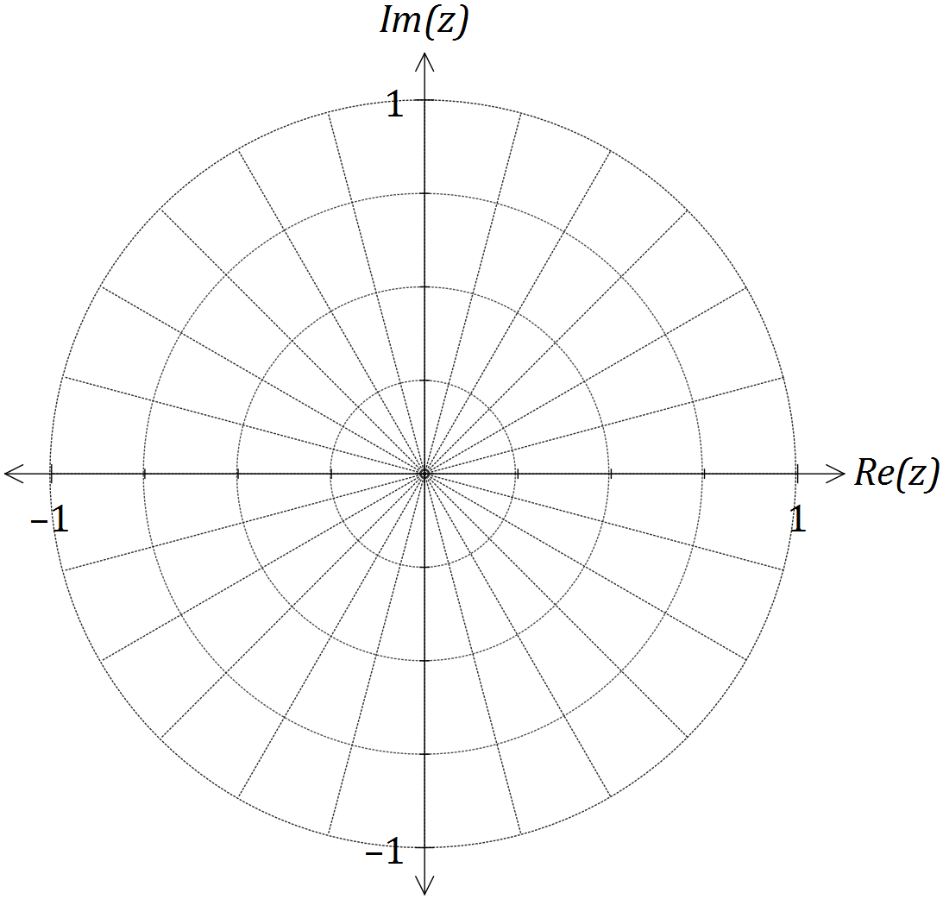

Question 3 (8 marks)
Two functions are defined by $f\left(x\right)=\sqrt{3x-1}$ and .

(a) Determine the composite function $f(g\left(x\right))$ and the domain over which it is defined.
(3 marks)

(b) Sketch the graph of $y=g(g\left(x\right))$ on the axes below. (2 marks)

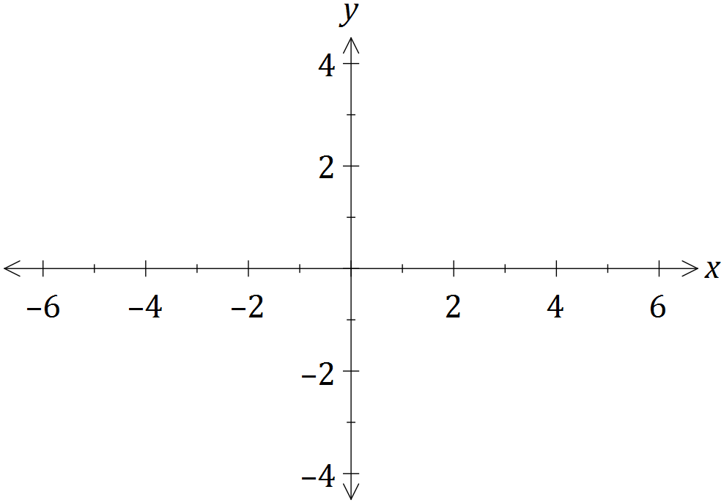

- The graph of $y=f\left(x\right)=\sqrt{3x-1}$ is shown below, passing through point $P$with coordinates $(2.62, 2.62)$.

Determine an equation for $f^{-1}(x)$, the inverse of $f(x)$, and sketch the graph of
$y=f^{-1}(x)$ on the same axes. (3 marks)

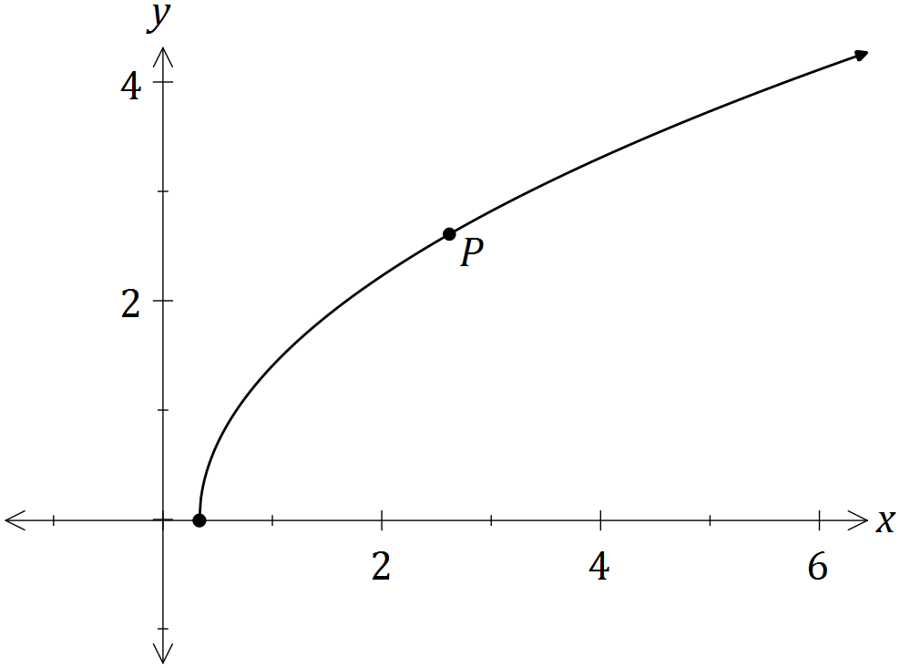

Question 4 (8 marks)
The function $f$ is defined as

(a) Show that the only stationary point of the function occurs when $x=0$. (2 marks)

(b) Sketch the graph of $y=f(x)$ on the axes below. (3 marks)

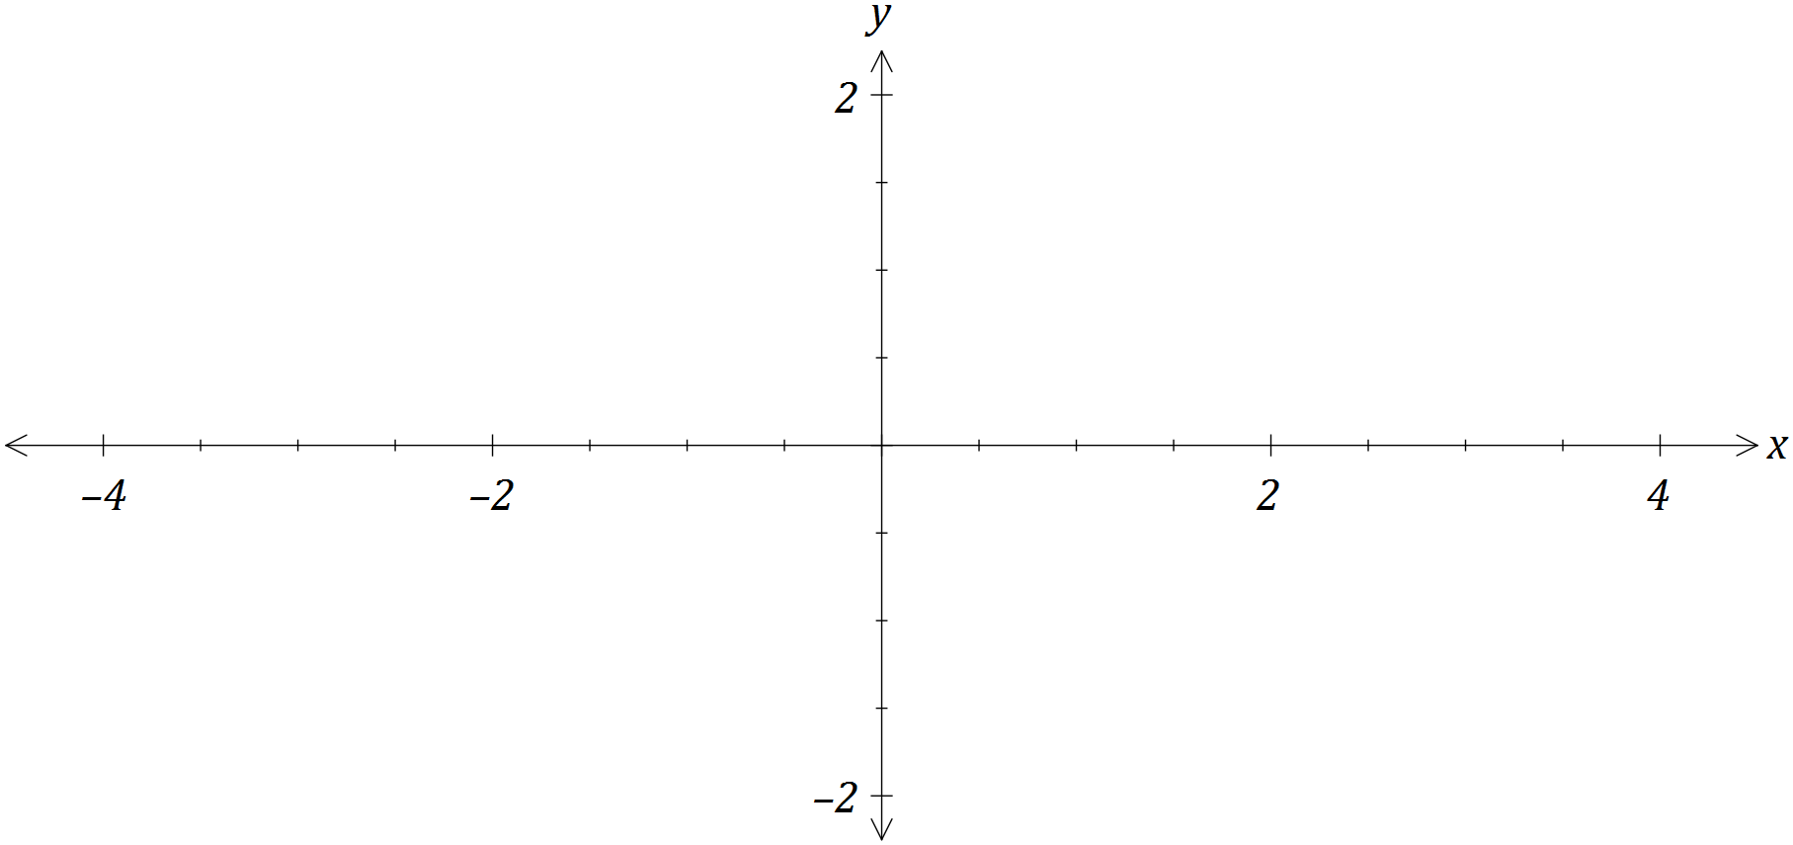

(c) Using your graph, or otherwise, determine all solutions to

(i) $f\left(x\right)=\left|f(x)\right|$. (1 mark)

(ii) $f\left(x\right)=f(\left|x\right|)$. (1 mark)

(iii) (1 mark)

Question 5 (7 marks)
(a) Using partial fractions, or otherwise, determine . (4 marks)

(b) Use the substitution $u=\sin{x}$ to evaluate (3 marks)

Question 6 (7 marks)
The graph of $y=f(x)$ is shown below, where $f\left(x\right)={4cos}^{4}{(2x)}$ and A is the smallest root of $f\left(x\right), x>0$.

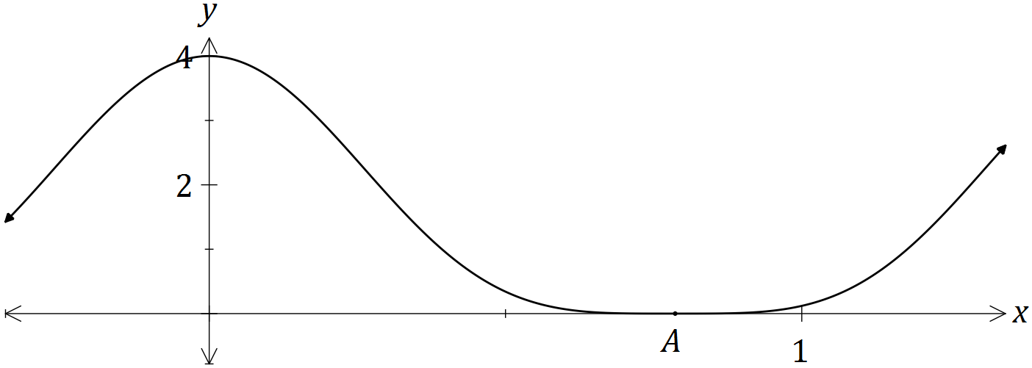

(a) Show that (3 marks)

(b) Hence determine (2 marks)

(c) Use the formula to write a definite integral to represent the volume of the solid generated when the region bounded by $=f\left(x\right),$ $y=0$, $x=0$ and $x=A$ is rotated through 360° about the x-axis. (2 marks)

Question 7 (7 marks)
(a) Show that the gradient of the curve $2x^{2}+y^{2}=3xy$ at the point $(1, 2)$ is $2$. (3 marks)

(b) Another curve passing through the point $\left(-2, 10\right)$ has gradient given by .
Use a method involving separation of variables and integration to determine the equation of the curve. (4 marks)

Question 8 (5 marks)
The differential equation is shown in just one of the four slope fields below.

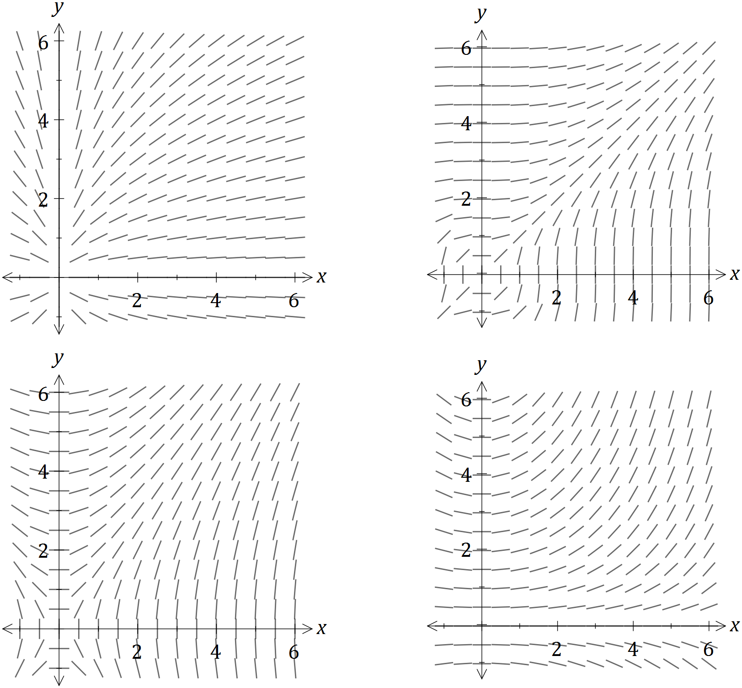

(a) On the slope field for sketch the solution of the differential equation that passes through the point $(2, 4)$. (3 marks)

(b) Another solution to the differential equation passes through the point $\left(6, -3\right).$ Use the incremental formula with to estimate the y-coordinate of this curve when $x=6.1$. (2 marks)

Additional working space

Question number: _________

© 2016 WA Exam Papers. Wesley College has a non-exclusive licence to copy and communicate this paper for non-commercial, educational use within the school. No other copying, communication or use is permitted without the express written permission of WA Exam Papers.

